Week 1, Your Camera and You.

A camera is really only a box, a light-proof box that acts as a container for your film. Most modern cameras also include:

The lens is an opening that allows light to come into the camera and expose the film. Images can also be formed by a pinhole in a thin piece of metal, but images formed by a lens are sharper and take less time to form on the film.

The aperture is a variable sized opening in the lens that regulates the intensity of the light passing through the lens.

The shutter is a curtain that opens and closes to regulate the duration of light coming into the camera and exposing the film.

An f-stop is a number that tells us how large the aperture opening is, and how much light it will let in. Full f-stops are: 1, 1.4, 2, 2.8, 4, 5.6, 8, 11, 16, 22, 32, 45, 64… The smaller numbers allow the most light through as they create the largest opening and conversely, the bigger numbers let in lesser amounts of light. As you go up or down the f-stop scale, each consecutive number allows in either twice or half of the light as the one next to it.
ie: f-2 lets in twice as much light as does f-2.8
f-2.8 lets in twice as much light as does f-4
f-4 lets in twice as much light as does f-5.6 etc…
Every lens is different, but no lens will have all of these f-stops. Typically lenses will go from f-2.8 or f-4 to f-16 or f-22. Don’t panic if your lens doesn’t have all of these f-stops!

Shutter speed tells us how fast or how long we are allowing light to hit the negative. Typical shutter speeds are counted in fractions of a second, they include:
1/1000, 1/500, 1/250, 1/125, 1/60, 1/30, 1/15, 1/8, 1/4, 1/2, 1 second and “B”. Note that each consecutive shutter speed is either double or half of the of the one next to it.
The “B” on your shutter speed dial is from the fairly archaic term “Bulb” which allowed the photographer to keep the shutter open as long as the rubber bulb was compressed. Thus, setting your shutter speed on “B” will keep your shutter open as long as the button is compressed.
Some cameras also may have a “T” on the shutter speed dial. This stands for “time”; when using the “T” setting the shutter will stay open until the shutter release button is pressed a second time.

The meter is a variable gauge that tells us when an appropriate amount of light is coming into the camera to correctly expose the negative. For the meter to work properly,
the ISO (film speed) of your film must be set on the camera. Some cameras set the film speed automatically through a DX or bar code that is read by a sensor on the inside of the camera.

Film speed or “ISO” describes the sensitivity a film or digital sensor has to light. The higher the number, the more sensitive (or faster) the film, and the less light it needs for a correct exposure.

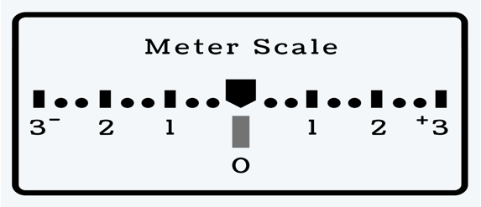 Example of a typical digital camera meter

