# Crop a Picture/Rotate a Picture

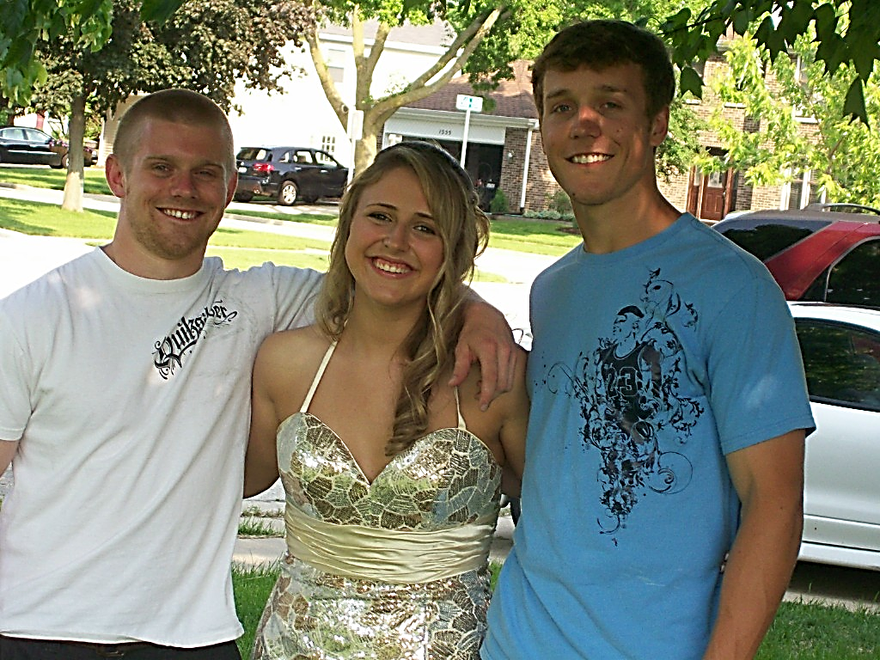

# Picture Corrections - soften/sharpen brightness/contrast



# Borders/Picture Effects/Position/Wrap Text

**.**

**Format a picture using the picture tools tab**

**They flap their wings so wide  
And glide through air like kites  
These butterflies are a pretty sight  
They’re truly amazing and a delight**

**In pairs and multiples they hover around  
They stop and rest where flowers abound  
Then hop, and dance, and flutter about  
In rhythmic patterns so rapid and sound**

**Each time I wake up in the beautiful morning  
These butterflies greet me by flapping their wings  
They brighten my days as I see them floating  
In air as they fly they seem to be dancing**

# Remove Background/Artistic Effects



MC900186204[1]****

# Tabs

**Tabs**

Construction Remodel 20,000.

Computers 25,000.

Communication 900.

Equipment 15,000.

Insurance 2,500.

Rent 10,000.

Marketing 3,000.

Legal 7,500.

# Insert a Table

# Convert Text to a Table

**By Salesperson**

**Salesperson Print TV Web**

Jim M. $10,252 $25,560 $13,745

Beth W. $5,550 $13,470 $27,800

Luiz D. $8,547 $17,555 $8,907

Alice S. $13,578 $6,789 $10,239



# Insert A Text Box

# Tracking Changes

To Whom it May Concern:

Thank you for taking the time to meet with with me last Thursday about the Sales Associate position. I enjoyed meeting with you and touring the faculty. I was very impressed with the layout of the showroom and competents of the staff at your company. I would love the chance to work in such a productive and very supportive atmosphere.

As we talked about, my many years of sales experience, both in commissioned floor sales and in the role of Sales Supervisor, would greatly benefit Quality Furnishings. In that time, I have learned many techniques that would drive sales and drive customer satisfaction ratings at Quality Furnishings.

I wanted to let you know that I have recently received my certificate from the Superior SalesTraining program at the National Business Institute. Several techniques covered in the program are sure to bolster sales. I look forward to having the chance to implement them at Quality Furnishings.

Thank you again for your consideration in filling this position. Please feel free to contact me if you have any questions or would like additional information. I am looking forward to hearing from you soon.

# Using Styles for Headings/ Create an Automatic Table of Contents using Styles