Excel Basic
Uses for Excel
-Number Crunching
-Creating Charts and Tables
-Organizing Lists and Data
Menu Organization
Excel 2010 uses tabs and ribbons to organize the menu options.
Tabs
Ribbon

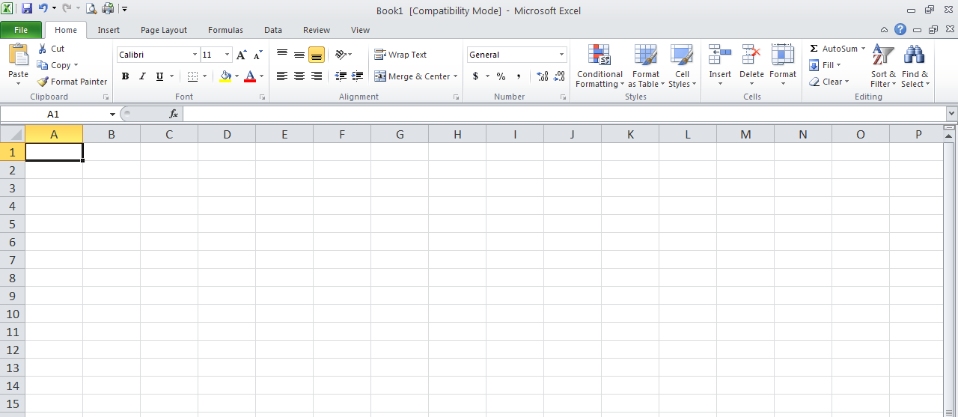
Many of the same functions you are used to seeing in Microsoft Word are also present in Excel. At the top of the screen you’ll notice the ribbons for “File”, “Home,” and “Insert”. You also have a section on the toolbar for editing your text. Just like Word, you can change the typeface, font, size, and color.

The Basic Layout
Excel is a spreadsheet organized into rows and columns. The rows are arranged in number order, the columns are assigned letters. There are about 16,000 columns and a million rows.
You have tabs at the bottom of your screen that will allow you to navigate between worksheets. By default you will be given 6 worksheets (labeled Sheet 1 through Sheet 6).
You can add, delete, rename, move, copy, color-code, etc. your worksheets by right-clicking on the tab you wish to edit. That will bring up a small menu with all your tab options.
You can zoom in or out of your spreadsheet using the slider control in the lower right of the spreadsheet.

Navigating and Entering Data
Excel navigation can be done in a number of ways. Excel uses cells. Cells all have names or cell references. Cell references are simply the letter and number where columns and rows meet. For example:
The active cell in this spreadsheet is cell C5. The cell reference is the place where the columns and rows meet. In this case, the active cell is at the intersection of column C and row 5, so the cell reference is C5.

There are a number of ways to navigate your spreadsheet. You can use the mouse and single click the cell you’d like to work in. You can also use the “tab” key to advance the active cell one column to the right. You can use the “enter” key to advance the active cell one row down. You can also use the direction keys to move your active cell around your spreadsheet.
To enter data into Excel you can select the cell where you’d like to enter information and begin typing. If you prefer, you can select the cell where you’d like to enter data and then type it in the formula bar at the top of the screen.
formula bar
If the data you enter is too long for the cell, you can use the mouse to alter the width of your columns or the height of your rows to accommodate the text. To change the width of a cell, place your mouse pointer on the division between the column letters, click and drag the cell until the width is acceptable. Another option is to double click on the division between the two columns. That will auto fit the column to fit the text.
Click and drag (or double click) here to widen column 2.
Selecting and Deleting Data, Cells, Rows, and Columns
Highlighting is an important skill that is used frequently in Excel worksheets. Highlighting in Excel works the same way as highlighting in Word, PowerPoint, or other Microsoft products. To highlight in Excel, you click and drag in order to select a given cell and/or area.
You can also highlight entire rows or columns. Do that by clicking on either the column letter or row number. Select multiple columns by clicking and dragging across multiple column letters or by holding down “Shift” and selecting the first and last column in your desired range.
Holding down “Ctrl” allows you to select noncontiguous columns, rows, or cells.

AutoFill
When you make a cell active in the worksheet a small fill handle appears in the lower-right corner of the cell. You can use the fill handle to create an AutoFill series. This will work with text, dates, numbers, years, and other types of data.
Let’s Autofill the dates in our spreadsheet. Start by placing your mouse pointer over the small square located in the bottom-right of the active cell. Your pointer will turn into a black plus sign when you’ve placed it properly. Click and hold your left mouse button and drag downwards as Excel fills in your dates.

Once you have clicked and dragged all your dates, you’ll notice you now have a smart tag for your AutoFill options. This will allow you to change what Excel displays (maybe you wanted the dates listed by months instead of days, for example).

Formulas
Formulas are what you use to perform calculations within your Excel spreadsheets.
Formula Structure:
Excel formulas work a little differently than you may be used to. Usually, you’d expect to see a formula that looks like this: 2+2=4. When using Excel, the “=” always comes first. This is your way of telling Excel that you are using a formula and not just typing text. Anything after the “=” is recognized as part of the formula. You always type your formula in the cell you want your answer to be in.
Mathematical Operators:
+ Addition
- Subtraction
* Multiplication
/ Division
Referencing Cells:
Although you can enter specific values in your Excel formulas, you can also easily reference data in specific cells. So, instead of your equation being =2+2, it could read =A1+B1. It is often preferable to use cell references instead of numbers so that if you have to go back and change the numbers in your data set, your formulas will automatically adjust to the change.
In our spreadsheet, if you wanted to find the answer to “Total” for column B or “Morning” this is what your formula would look like: =B4+B5+B6+B7+B8+B9+B10+B11+B12+B13+B14
For right now, just find the total for cell B16. We’ll use something else to find the minimum, maximum, and average answers.
Luckily, to create this long formula, you don’t have to type everything out. Start with your “=” and then click on the first value (B5). Then, enter your “+” and then click on your second value. Repeat this until all of your cells have been included in the formula. Then, hit the “enter” key or click outside of the cell to get your answer.

Basic Functions
Function Elements:
Because functions are a type of formula, they must also start with an “=”.
Functions are different in that they each have a name. For example, the name of the function for addition is “sum.” You can type functions directly into your worksheet or you can use the Insert Function dialogue box to help you construct functions.
Structure:
Functions use arguments to indicate the cell addresses you want the function to calculate. The arguments (cell references or cell addresses) are contained in parentheses. You can use commas to separate the arguments, or you can use a range.
Using a Range:
A range is an easier way of entering a series of cell addresses into a formula. Let’s demonstrate using a range by finding the total for column C:
-Start with “=”
-Since we are adding the column, we need the function for addition, which is “sum”. Type “sum” after your “=”.
-Open your parentheses.
-Enter your range. You could enter the references individually separated by a comma, but using a range is an easier way to include your references. Start with C4. Click and drag your mouse pointer from C4 all the way to C14. Take a look at your function. Excel should’ve inserted “C4:C14”. That is a range. The range starts with C4 and ends with C14. The “:” in between should be read as “through.” Thus, this forms an equation that says: “EXCEL…add C4 through C14.”
-Don’t forget to close your parentheses!
Click here for the function dialogue box
Common Functions:
SUM Addition
MIN Minimum
MAX Maximum
AVERAGE Average
PRODUCT Multiply

Find the answers for Maximum, and Average for columns C and D by choosing the appropriate function name and creating your own function.
AutoFunctions
Excel makes creating functions even easier with automatic functions. AutoFuctions do all the work for you!
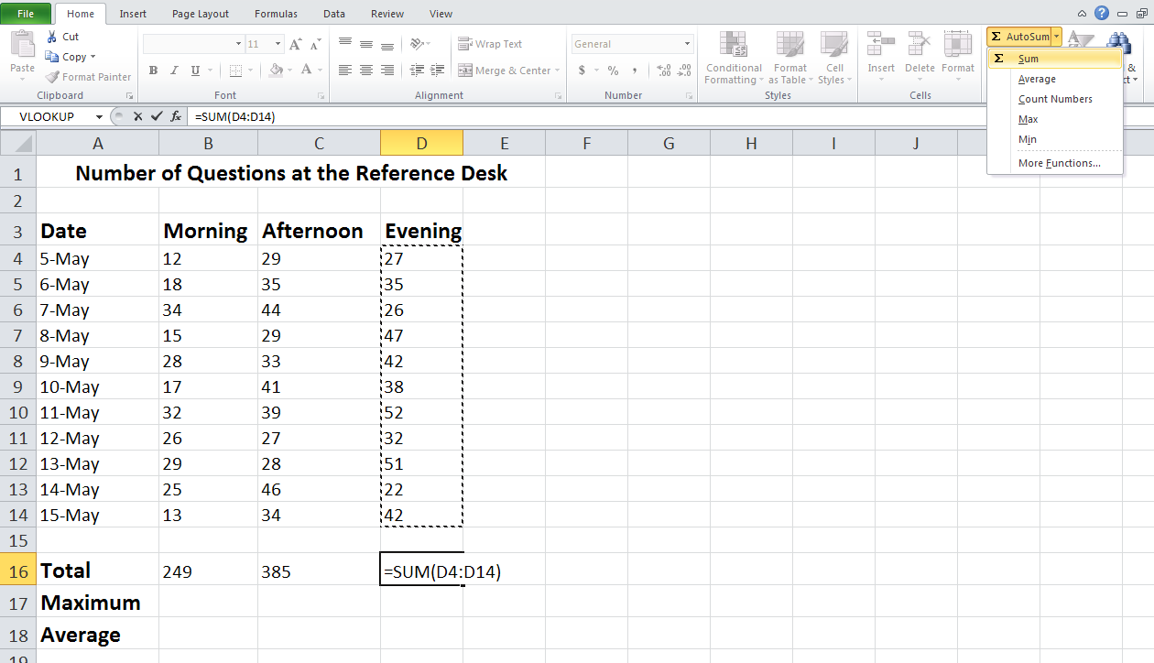
Pay attention to what AutoSum selects for your range. Make sure it is correct!
If it isn’t, simply click and drag to include the correct range.
Click the arrow next to the AutoSum button to select a different auto function.

AutoSum
You can use Auto functions for many different functions in Excel (AutoMinimum, AutoMaximum, AutoAverage, etc.).
This is what your finished spreadsheet should look like:

Charts and Graphs
Making charts and graphs from Excel data is easy. Highlight the data you wish to include in your graph. Click on the “Insert” ribbon, then choose from a wide variety of chart types and sub-types. Not all chart types work for all types of data but it’s very easy to switch between different types of charts until you find the one that works the best.
“Insert” Ribbon
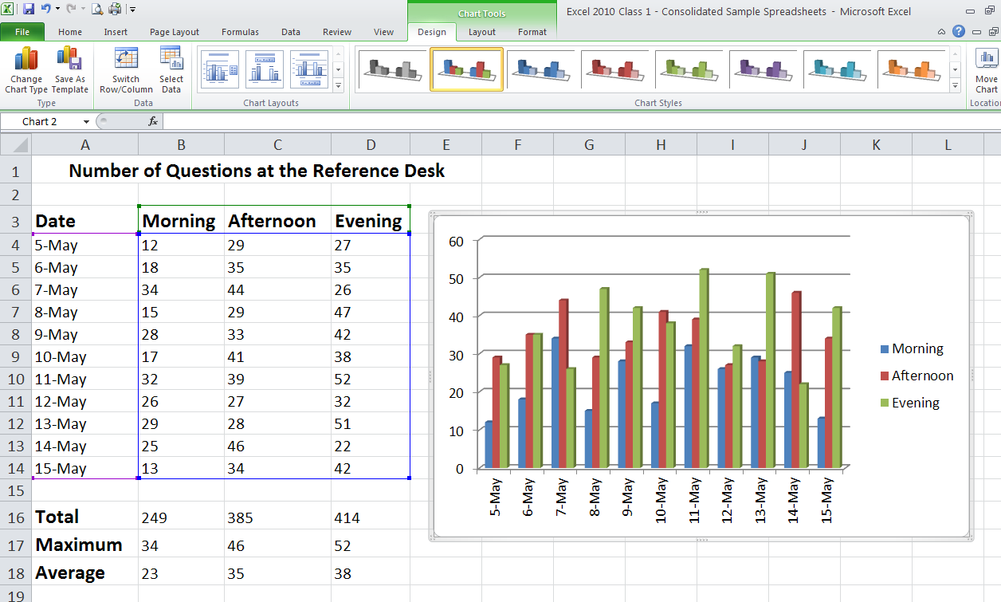
Notice the new contextual tab called “Chart Tools”

Calculating Formulas in Excel
Calculating the percentage of a whole:
Here is the basic formula:
Percentage of a Whole = Points Answered Correctly (number 1) / Total Points Possible (number 2)
This formula divides the total points correct by the total points possible in order to get a percentage of points correct.
Calculating sales tax and total sale:
Here is the basic formula:
Sales Tax Dollar Amount = Purchase Price (number 1) * Sales Tax Percent or Decimal (number 2)
Total Sale = Purchase Price (number 1) + Sales Tax Dollar Amount (number 3)
These formulas tell Excel first to multiply the Purchase Price by the Sales Tax Percentage or Decimal to get our Sales Tax Dollar Amount, then add the Purchase Price to the Sales Tax Dollar Amount.
Calculating an increase or decrease of a number by a percentage
Here is the basic formula:
Increased Number = Original Dollar Amount (number 1) *(1 + Percent Increase (number 2))
Decreased Number = Original Dollar Amount (number 1) *(1 – Percent Decrease (number 2))
These formulas are telling Excel to take your original dollar amount and multiply it by 1 minus or plus the percent increase/decrease.

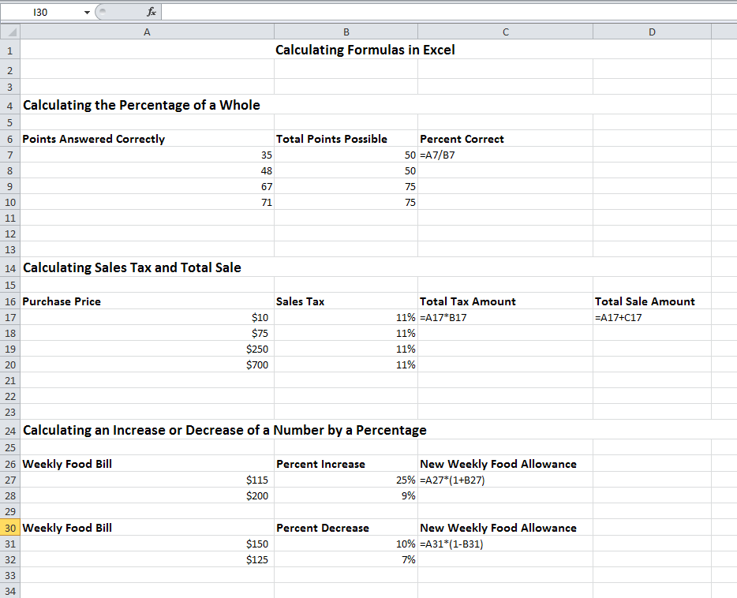

Relative Cell References vs. Absolute Cell References
When Excel performs the AutoFill function, it will by default adjust the cell references in the formula as it moves down each row of data calculations:
Notice that after AutoFilling the Salary Owed column, the cell references in each number’s formula changes to correctly reflect the different rows. Because the cell references in each number’s formula changes, these are called “relative cell references.”

Sometimes, however, you will want all formulas in a column to refer to a fixed number; such is the case when calculating taxes, since the same tax rate applies to each row. By referring to this fixed number, you can easily change the tax rate later and have the change automatically apply to the entire column without having to make changes to each formula.
In this example, an absolute cell reference has been created for the tax rate in cell B14. In creating the first formula in column F, dollar signs ($) have been placed in front of the column letter and row number of the absolute cell reference. These dollar signs tell Excel to reference the exact same cell for the tax rate when AutoFilling the rest of the column.
If you want to change the tax rate in the future, changing the tax rate number in cell B14 will now automatically apply the change to all formulas in column F.

Formatting Font and Alignment
The tools for changing the formatting of your worksheet can be found on the Home ribbon. If you are familiar with Microsoft Word 2010, you will recognize many of the same options, plus some additional features unique to Excel 2010.
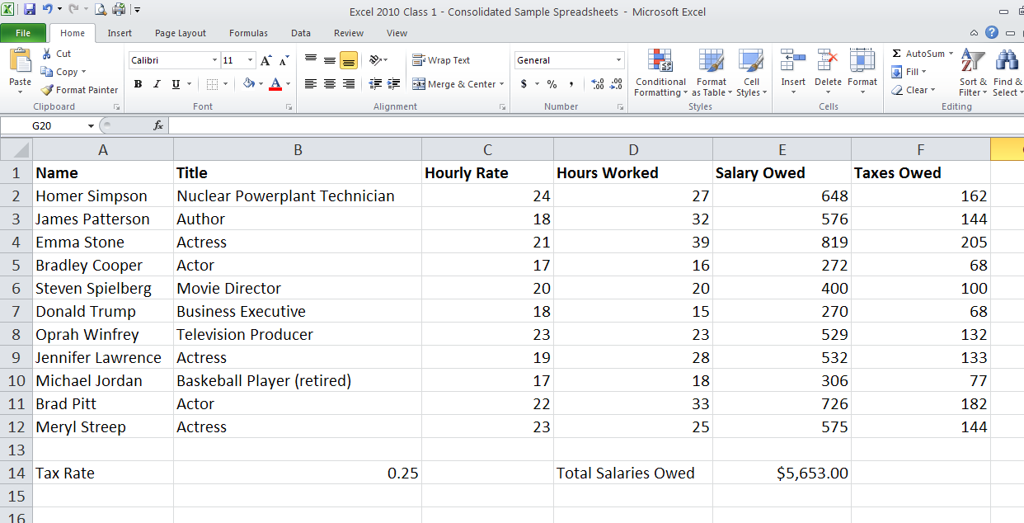
Some of the available formatting options are font style, font size, bold, underline, fill color, letter color, and cell borders. You can also adjust the position of text within the cells, centering data vertically or horizontally, left justifying, right justifying, wrapping text, etc. In this example, the heading row has been selected and various formatting changes have been applied:
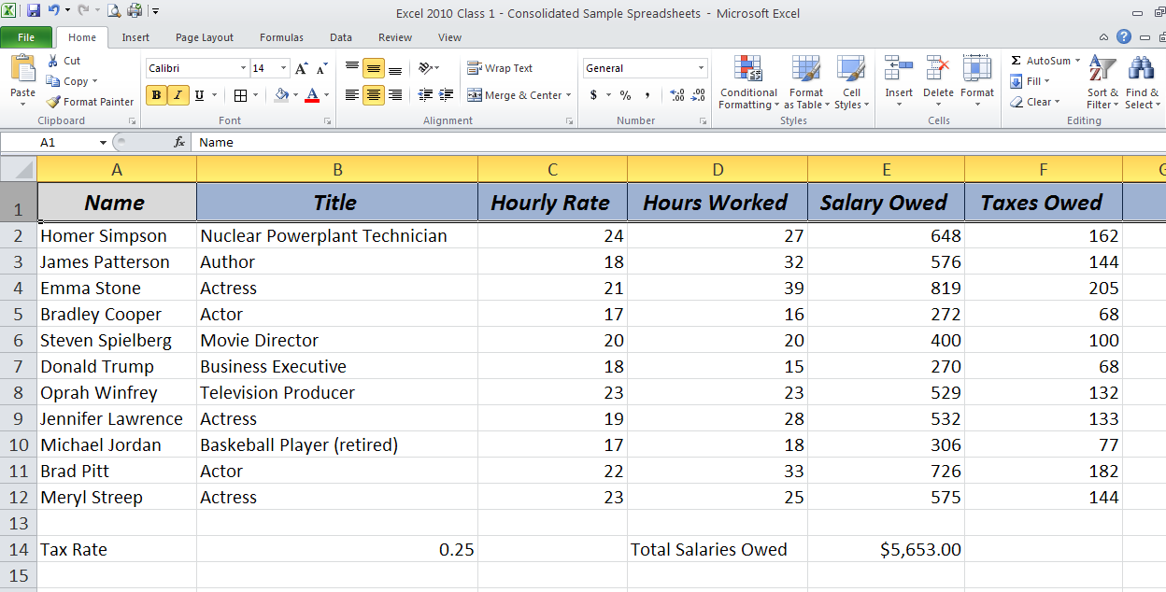
Formatting Numbers
Since Excel is designed for number crunching, it is frequently necessary to format numbers in order to tell Excel whether you are dealing with currency, percentages, decimals, whole numbers, etc. These, plus other number formatting options, can also be found on the Home ribbon.
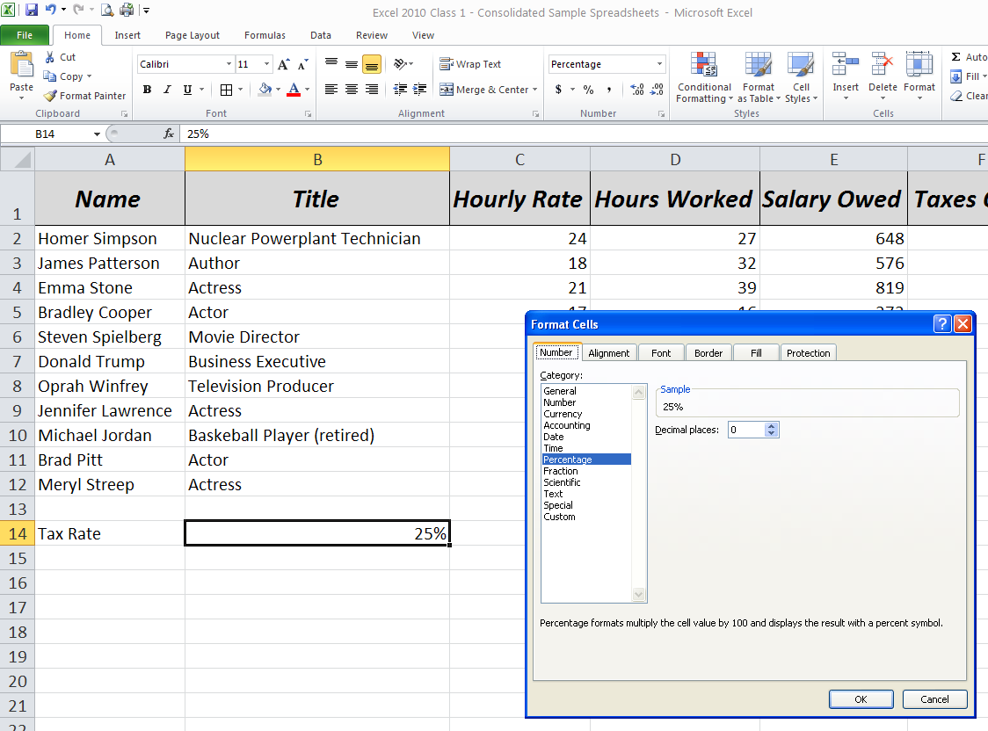
In this example the tax rate of 0.25 was highlighted, then the % button was selected on the ribbon, converting the decimal to a percentage. You can also change the formatting by selecting the cell, right clicking the mouse, selecting the number category you want, and, if needed, adjust the number of decimal places. Click OK.
These same methods can be used to apply other changes to the numbers on your spreadsheet. In this example pay rates, salaries, and taxes have been formatted to include dollar signs and two decimal places per number. You will notice that right clicking and selecting the formatting menu allows you to adjust the decimal places and also gives you options for choosing how you want negative numbers to appear: with a negative symbol, in parentheses, in red, etc.

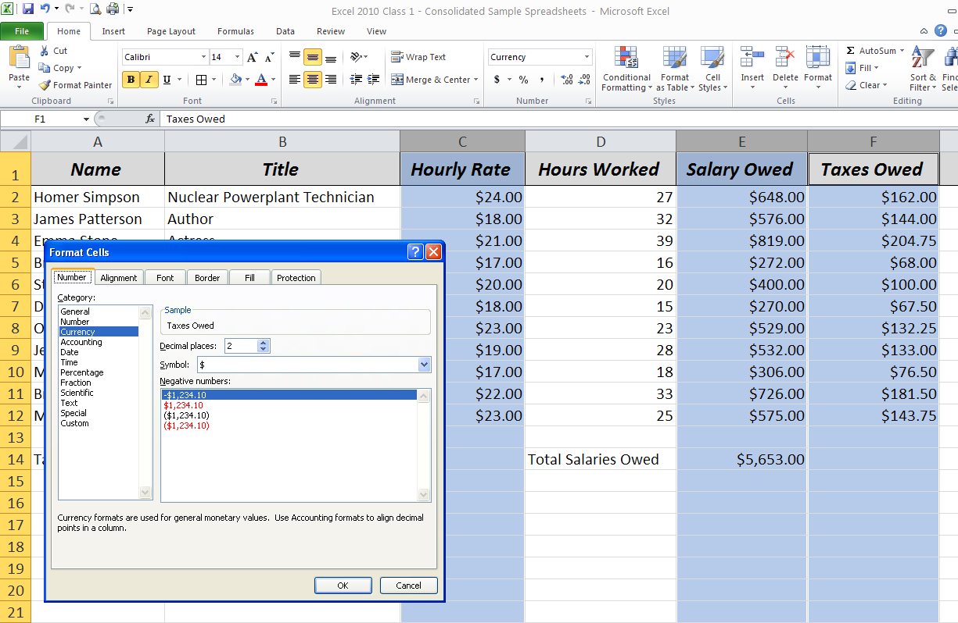
Cutting and Pasting
Cutting and pasting data in Excel 2010 is a little different from cutting and pasting in other Microsoft programs. Sometimes data has an underlying formula or function so Excel needs to know if you want to cut and paste the answer to the formula or the formula itself.
Right click on the cell you wish to copy and paste, then select “Copy.”

Select the cell you wish to paste to, then right click to view your paste and “paste special” options.
The paste option that looks like a clipboard with “123” on it pastes the number only without the underlying formula (see example above). If you had selected the “fx” paste option, Excel would paste only the formula and would try to determine what relative cell references to use in the newly pasted formula. If you choose to paste only the formula, make sure Excel is using the correct cell references.

Copying a Spreadsheet
After spending a considerable amount of time creating and adjusting your spreadsheet, you might find it useful to copy the completed spreadsheet to another tab or workbook so that you do not have to recreate it from scratch the next time you need to make a similar spreadsheet. Right click the bottom tab of your spreadsheet and click “Move or Copy”
You can move your spreadsheet to another workbook or simply to another tab in your current workbook. Don’t forget to check “Create a copy.”
Click OK and you will notice that an exact duplicate has been created. Now you can use the duplicate spreadsheet as a template for a new spreadsheet.
Merge and Center
In addition to centering data within a cell, Excel 2010 also allows you to center text across multiple columns using the Merge & Center option. This is ideal for centering a heading across a spreadsheet.
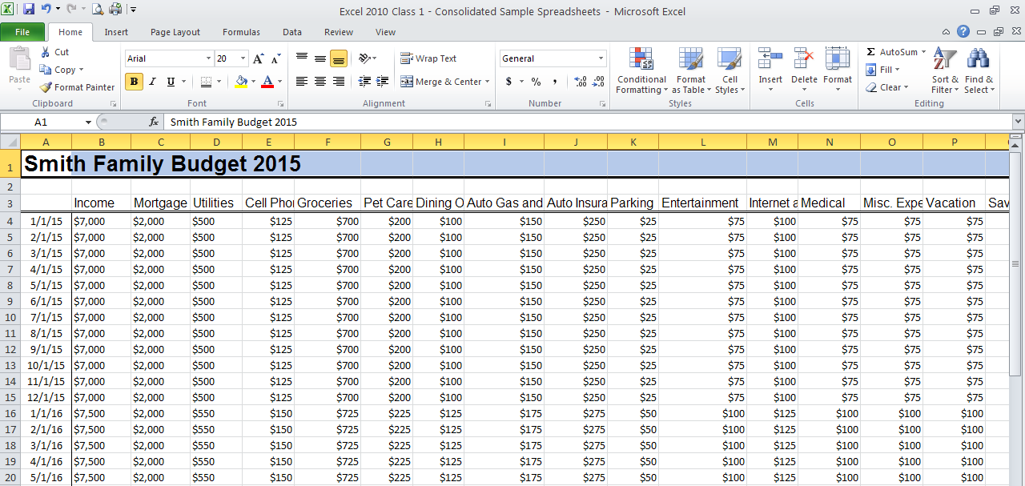
Begin by highlighting your text-including any empty cells you want your text to be centered across. In this case cells A1 through Q1.

Click on Merge & Center. This will remove your gridlines and center your text across the cells you highlighted.

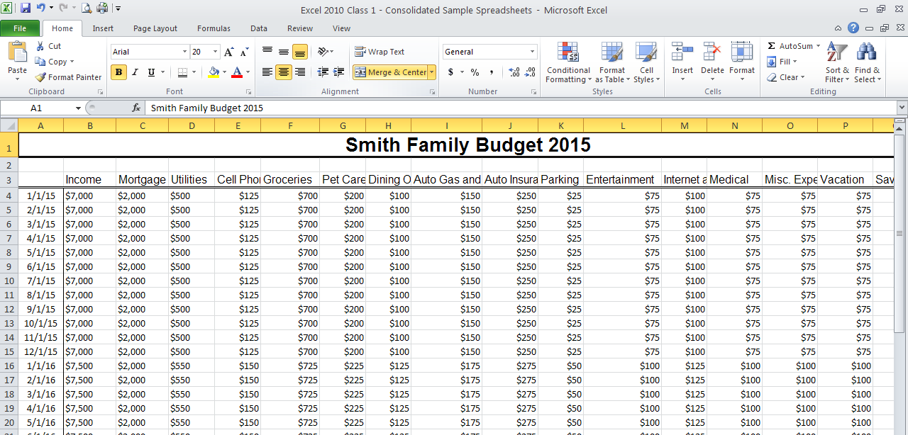

Wrapping Text
Text Wrapping allows you to fit all of your text in one cell. By default, text in Excel that is longer than the cell will overlap into the cells next to it, truncating the text. Wrapping tells Excel that instead of going into the next column, wrap the text around within the cell (making the row height increase.)
Start by selecting the cell(s) you wish to edit. In this example, select Row 3. Then, click “Wrap Text.”
The column headings now all fit within the width of their cells.

Adding and Deleting Columns and Rows
Adding or Deleting columns and rows to your spreadsheet is easy. To add a column: click the heading of the column to the right (or row below) of where you want to insert a new column. Right-click the selected column and click insert.

After highlighting Column E, right click with your mouse. You will see this menu to insert a new column.
The new column will appear to the left of the column you highlighted.
When inserting rows, new rows will appear above the row you highlighted.
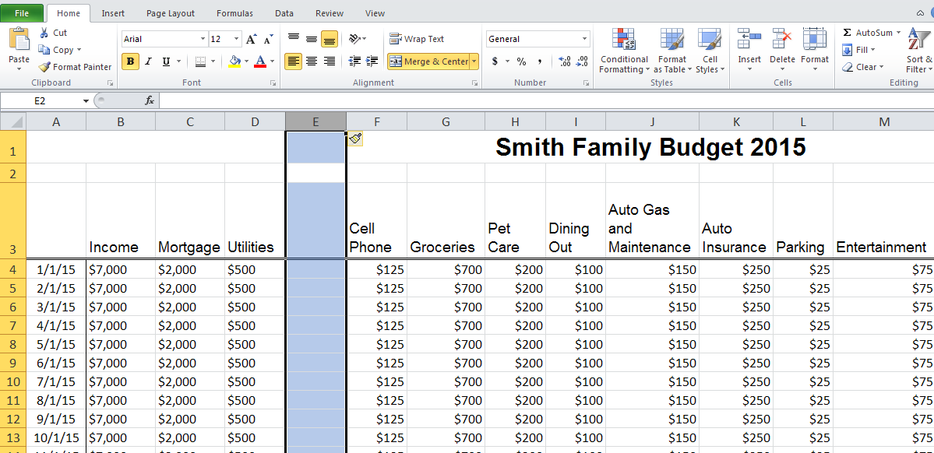
To delete a column or row, select the column or row, right-click, and select delete. Note: using the “Delete” key on the keyboard will only delete the row or column’s contents, not the row or column itself.

Deleting Cells and Data
Deleting cells and data can sometimes be tricky. Pay attention to the options carefully and remember to use your undo button if you need too!
To delete just the data in the cells (not the cells themselves) click the cells or range you want to delete. Pressing the “Delete” key will erase the data in the cells. Or, you can highlight the cells you want to delete, right click with your mouse and choose” Clear Contents.” Both methods will only remove the data in the cells.
Deleting cells is where things get a little tricky. To delete cells, select the cell or cells you would like to remove. Right-click over the cell or range. Click “Delete”. The Delete Cell dialogue box will appear with a few options.

Tell Excel what you want to do with the missing space/cells, and then click OK.
Hiding and Unhiding Columns or Rows
If you have a large spreadsheet that has a lot of rows and columns of data, sometimes it is helpful to temporarily hide the rows or columns that you are not using at the moment. To hide a column, for instance, you can select the letter at the top of the column, right click, and select “Hide.”
In this example, column E has been hidden. In its place, you will see a dark black vertical line reminding you that information is hidden.

When you wish to unhide the column, simply highlight the columns on either side of the hidden column, right click, and select “Unhide.”
The hidden column is now visible.

Freezing Columns or Rows
You can freeze a portion of your spreadsheet, such as your headings, so that if you scroll down or to the right your column and row headings will remain visible at all times.
Select the row below and/or the column to the right (in this example B4) of the area you wish to freeze.
Then, go to the View tab and to “Freeze Panes.”
To unfreeze, go back to “Freeze Panes” and an option will appear to “Unfreeze Panes.”
Protecting Your Spreadsheet
Protecting your Excel spreadsheets is a good idea if multiple people have access to the spreadsheet. You can protect a single worksheet or an entire workbook. Choose the Review Ribbon and you will then see the “Protect” options.
When you place protection on a spreadsheet or workbook you are making sure no data can be changed. You will need to create a password to turn off the protection. Make sure to remember your password because there is no way to look it up. To remove the protection, make sure you are in the Review Ribbon, click “Unprotect Sheet” and enter your password.
Printing Options
Choosing the Page Layout ribbon allows you to set up how you would like your spreadsheet to look when you print it.
The “Scale to Fit” option allows you to change the size of your data by adjusting the percentage. Just be careful - lowering the % of normal size or fitting large amounts of data on very few pages can make your text and data small and difficult to read.

The “Orientation” option allows you to switch from portrait to landscape orientation and adjust the scale of your spreadsheet
The “Margins” option lets you adjust your margins and gives you the option of centering your spreadsheet horizontally or vertically on the page.

You can also select the paper size, set page breaks, and set a background color or image.
The ”Sheet Options” can also be helpful when printing. You can choose to print the gridlines and headings (the column letters and row numbers) by checking the boxes for printing.

Questions?
Feel free to contact me at
Arthur Krull
Palatine Public Library District
847-385-5881 x 193
akrull@palatinelibray.org

