**A Hippopotamus Got on a City Bus**

A hip, a hip, a hippopotamus got on, got on, got on a city bus and all, and all, and all the people said, "You're squishing us!" (*Hug baby*)   
  
A cow, a cow, a cow got on the bus and all, and all, and all the people said, "Mooooove over!" (*Shift Baby to the Side*)  
  
A sheep, a sheep, a sheep got on the bus and all, and all, and all the people said, "Baaaack up!" (*Bring the Baby Backwards toward you)*

**Goodnight Moon** By Margaret Wise- 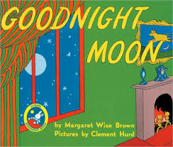

Lap Bounce Action

Book of the Day

**Shake Your Eggs and Stop**  
  
3x Shake Your eggs and STOP  
3x Roll your eggs and stop  
3x Tap your eggs and STOP  
3x Shake your eggs and STOP  
3x Up and Down and STOP  
3x Shake your eggs and STOP

Early Literacy Tip

Re-reading the same book over and over instills a love of reading, stories by forming "favorites".

Shaker Song