**Good Morning Song**  
  
*(Tune of: Happy Birthday)*Good Morning to You  
good morning to you  
Good morning dear (*baby’s name*)  
Good morning to you.

Welcome Song

**How Does Baby Feel?** by Karen Katz  
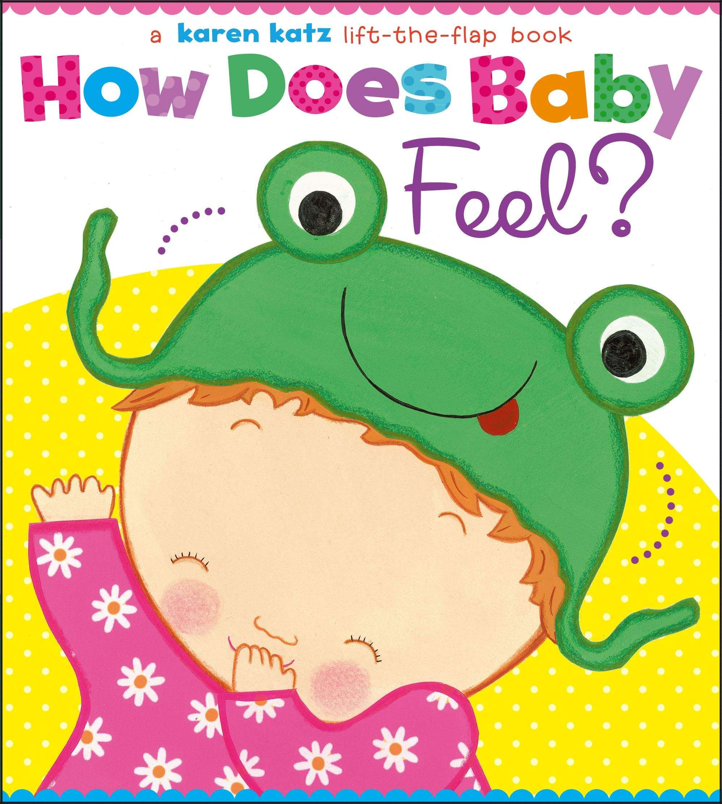

Book of the Day

Incorporating the baby's name into a song helps with name recognition as well as learning to associate meaning with sound.

Early Literacy Tip

**A Smooth Road**

*(Start bouncing baby softly, and increase intensity with the lyrics)*  
A smooth road, a smooth road, a smooth road, a smooth road.    
     A bumpy road, a bumpy road, a bumpy road, a bumpy road.    
     A rough road, a rough road, a rough road, a rough road.    
     A hole!  (*lift high and lower)*

Lap Bounce

**Shake Your Shakers**  
  
*(Tune of: London Bridge)*Shake your shakers, shake, shake, shake  
shake, shake, shake, shake, shake shake.

Shake your shakers, shake, shake, shake  
Shake your shakers

Verses: Shake your shakers high, high, high  
Shake your shakers low, low, low  
Shake your shakers fast, fast, fast  
Shake your shakers slow, slow, slow

Shaker Song