Excel Basics

Uses for Excel
- Number Crunching
- Organizing Lists and Data
- Creating Charts and Tables

Menu Organization

Excel uses tabs and ribbons to organize its buttons and menus. The most commonly used buttons are found on the Home tab.

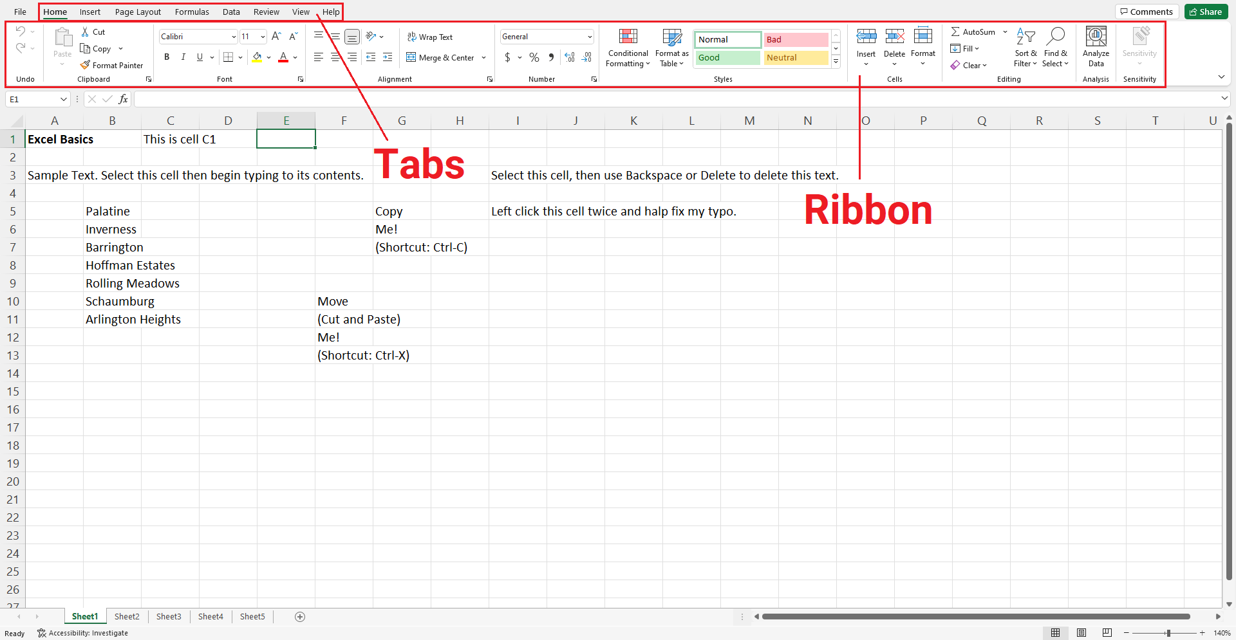

The Basic Layout

Excel is a spreadsheet application organized into rows and columns. Rows are arranged in number order, and columns in letter order. Excel files contain one or more worksheets, which are denoted by the tabs at the bottom of the screen. You can move, color, copy or delete worksheets by right clicking on the tab bearing its name, or add blank worksheets to your Excel file by left clicking on the plus-sign-within-a-circle button. You can also drag-and-drop worksheet tabs to reposition them.

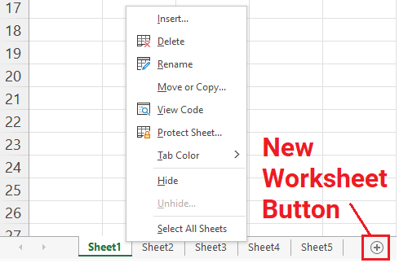

You can zoom in or out of your worksheet by using the slider in the lower right corner of the application.

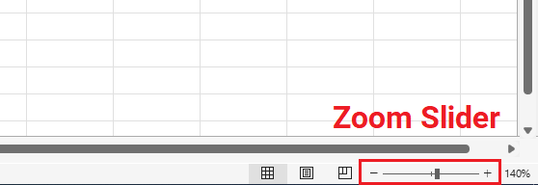

Navigating and Entering Data

Each Excel worksheet is a collection of data units called ‘cells.’ Cells are named according to their position, so the cells in the first column are named A1, A2, A3, and so on. The green border indicates which cells you currently have selected.

To select a cell, left click that cell. Use the arrow keys to move between individual cells. Additionally, the Enter key will move you one cell down, and the Tab key will move you once cell to the right. To select multiple cells, left click and drag your mouse cursor across the cells you wish to select, or left click on the header of a row or column to select that entire row/column. You can also select a cell, hold down Shift, and then left click on another cell to select the range of cells between.

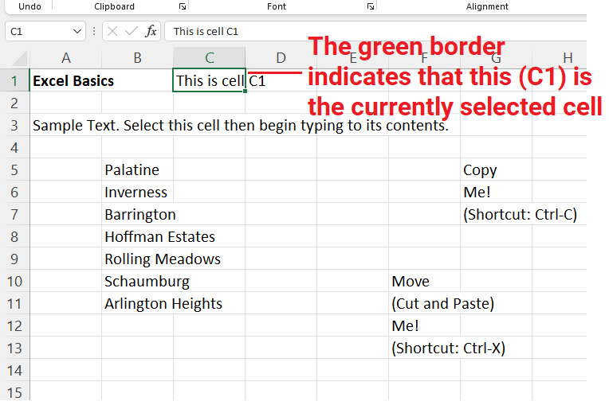

To enter data into a cell simply select that cell and begin typing. Please note that what you type will replace the previous contents of the cell, if any. If you wish to edit the contents of a cell instead, left click on that cell twice, or use the formula bar below the ribbon.

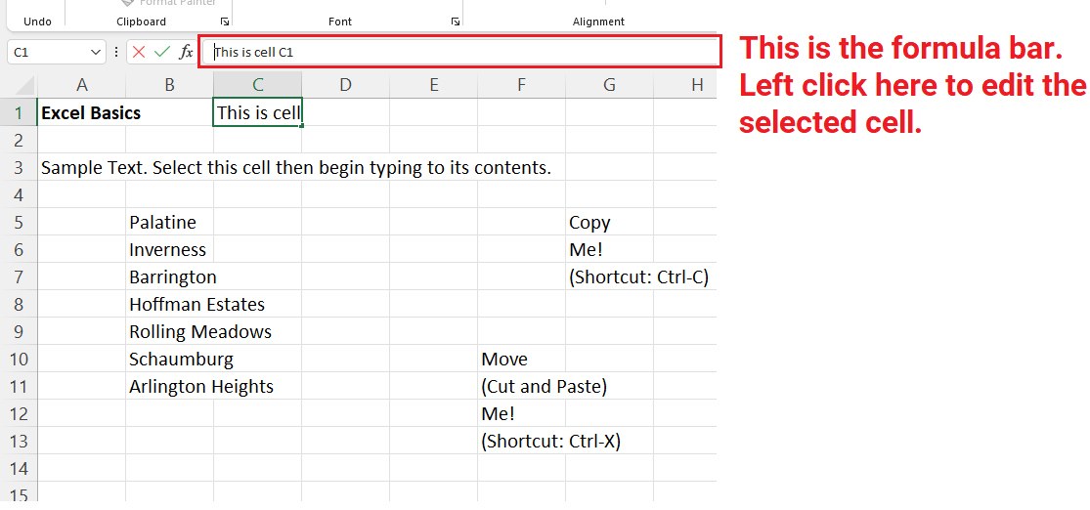
Deleting, Copying, and Pasting

You can use the Backspace or Delete keys to delete content from cells. Alternatively, you can delete the actual cells by selecting them, right clicking on the selection, and left clicking on the Delete… option. Deleting cells will shift adjacent cells around to fill the vacated space, so be careful when doing this. You can also insert blank cells by right clicking on a cell and left clicking on the Insert… option.

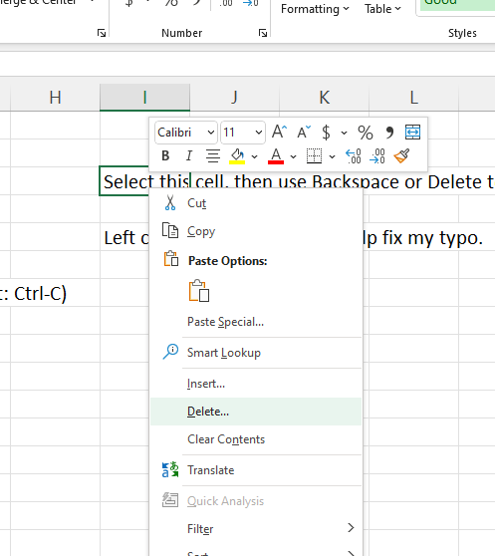

You can copy cells by selecting them, right clicking, and left clicking on the Copy option (shortcut: Ctrl + C). The cells to be copied will be highlighted by a green dotted border. Then right click on where you want to copy the cells to and left click on one of the Paste options (shortcut: Ctrl + V). You can also Cut (shortcut: Ctrl + X) and paste instead.

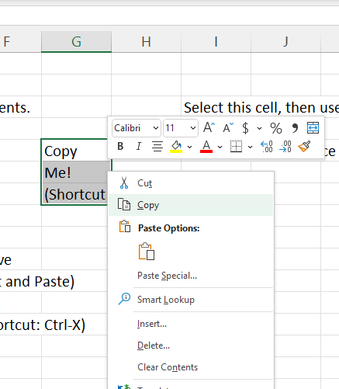

The Fill Handle

The fill handle is a tool you can use to quickly copy content to adjacent cells. To access the fill handle, move your mouse cursor to the bottom right corner of your selected cells, where your cursor should transform into a plus sign. When you see this, hold down the left mouse button and drag your cursor towards the cells you want to copy into.

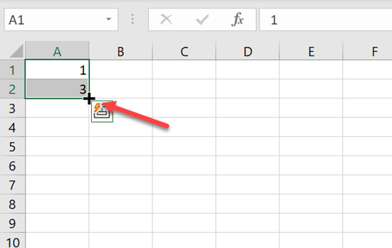
The fill handle can also be used to continue a series, such as of numbers or dates. In the example below the fill handle is used to complete the dates portion of the table.

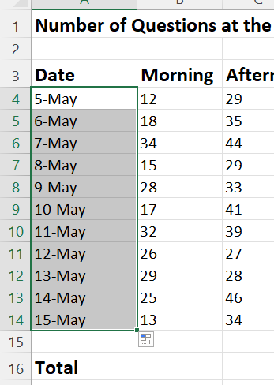

Formatting Columns and Rows

You can adjust the width and height of columns and rows by hovering your mouse cursor over the line in the column/row header dividing adjacent numbers or letters, and then holding down the left mouse button and dragging the column or row so that it is wider or narrower. Alternatively, you can double left click on a column header divider to have Excel automatically resize the column to the left of the divider to fit the cell with largest data.

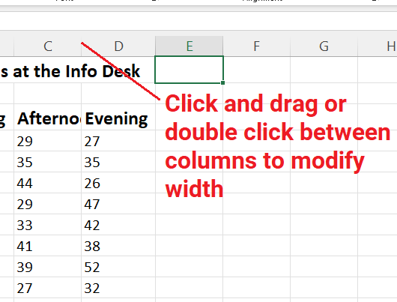

Formatting Font and Alignment

The tools for changing the formatting of your worksheet can be found on the Home ribbon. If you are familiar with Microsoft Word, you will recognize many of the same options, plus some additional features unique to Excel.

Some of the available formatting options are font style, font size, bold, underline, fill color, letter color, and cell borders. You can also adjust the position of text within the cells, centering data vertically or horizontally, left justifying, right justifying, wrapping text, etc. In this example, the heading row has been selected and various formatting changes have been applied.

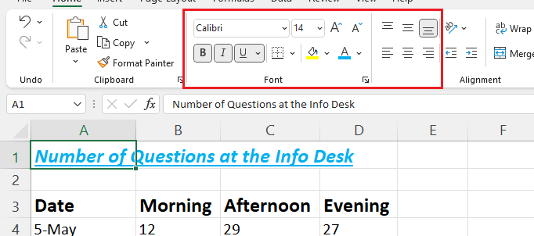

Formatting Numbers

Since Excel is designed for number crunching, it is frequently necessary to format numbers as currency, percentages, decimals, whole numbers, etc. These, plus other number formatting options, can also be found on the Home ribbon.

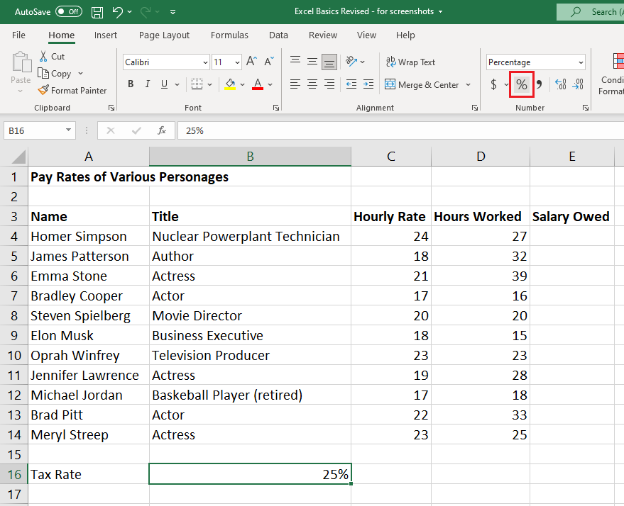

In this example the tax rate of 0.25 was highlighted, then the % button was selected on the ribbon, converting the decimal to a percentage. You can also reformat by selecting one or more cells, right clicking, and then selecting the number category and, if needed, adjust the number of decimal places.

These same methods can be used to apply other changes to the numbers on your spreadsheet. In this example pay rates and salaries have been formatted to include dollar signs and two decimal places per number. You will notice that right clicking and selecting the formatting menu allows you to adjust the decimal places and also gives you options for choosing how you want negative numbers to appear: with a negative symbol, in parentheses, in red, etc.

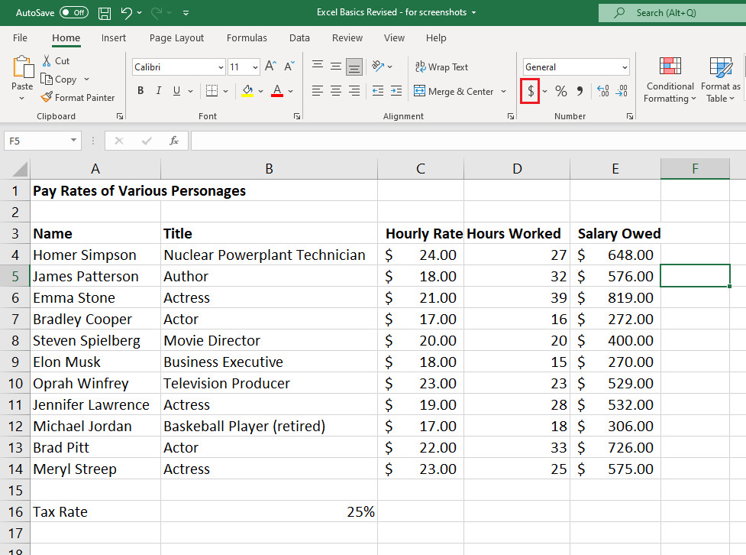

Inserting, Deleting, and Moving Columns and Rows

You can add blank columns or rows by right clicking on a column/row header and left clicking on the Insert option. Similarly, you can delete columns or rows by right clicking on their header and left clicking on the Delete option.

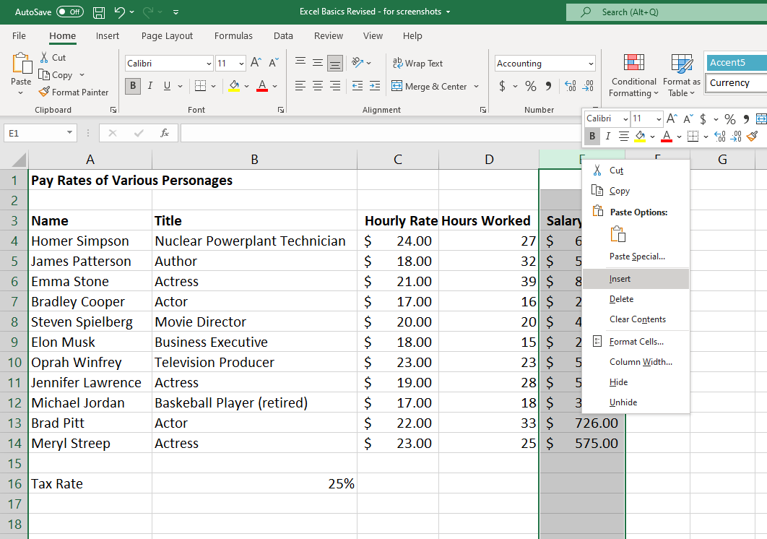

You can copy or move columns and rows by right clicking on their header and then left clicking on the Cut or Copy option. Then right click on where you want to copy/move the column/row to and left click the Insert Cut/Copied Cells option.

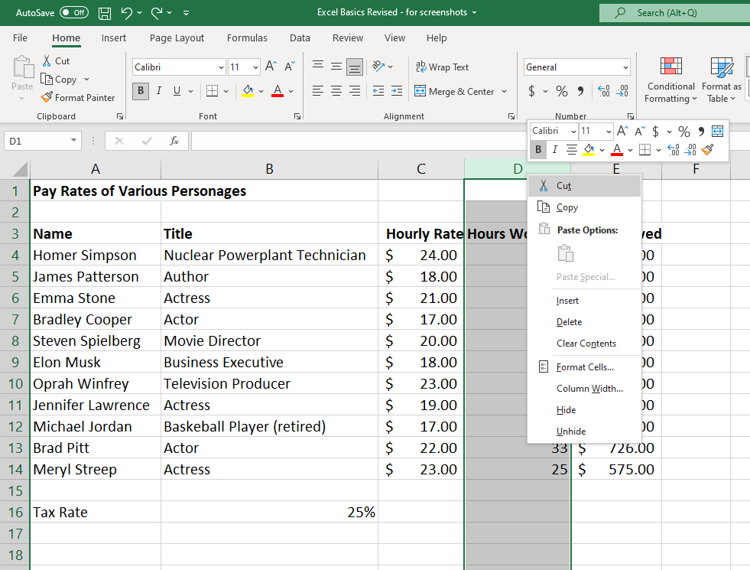
Formulas

Formulas are what you use to perform calculations within your Excel spreadsheets.

Excel formulas work a little differently than you may be used to. Usually, you’d expect to see a formula that looks like this: 2+2=4. When using Excel, the “=” always comes first. This tells Excel that you are using a formula and not just typing text. Anything after the “=” is recognized as part of the formula. You always type your formula in the cell you want your answer to be in.

Mathematical Operators:

+ Addition
- Subtraction
* Multiplication
/ Division

When you enter a formula into a cell, Excel automatically calculates the result of the formula and displays that instead of the formula itself. To view or edit the formula, double click on the cell or use the formula bar. To use more complicated formulas, remember the order of operations and use parentheses if necessary.

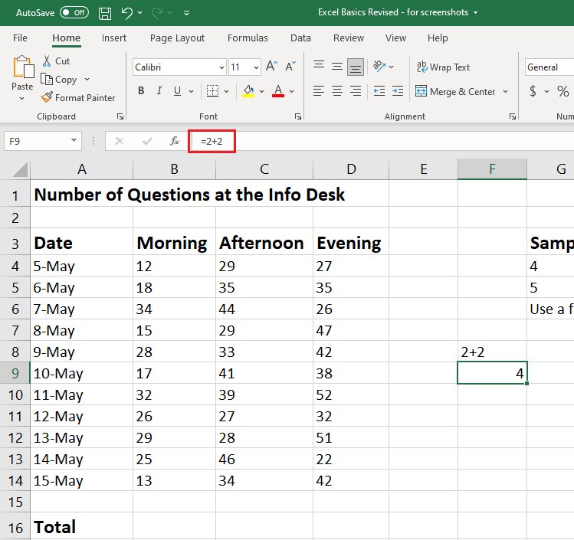

Referencing Cells

Although you can enter specific values in your Excel formulas, you can also easily reference data in specific cells. So, instead of your equation being =2+2, it could read =A1+B1. It is often preferable to use cell references instead of numbers so that if you have to go back and change the numbers in your data set, your formulas will automatically adjust to the change.

In our spreadsheet, if you wanted to find the answer to “Total” for column B or “Morning” this is what your formula would look like: =B4+B5+B6+B7+B8+B9+B10+B11+B12+B13+B14

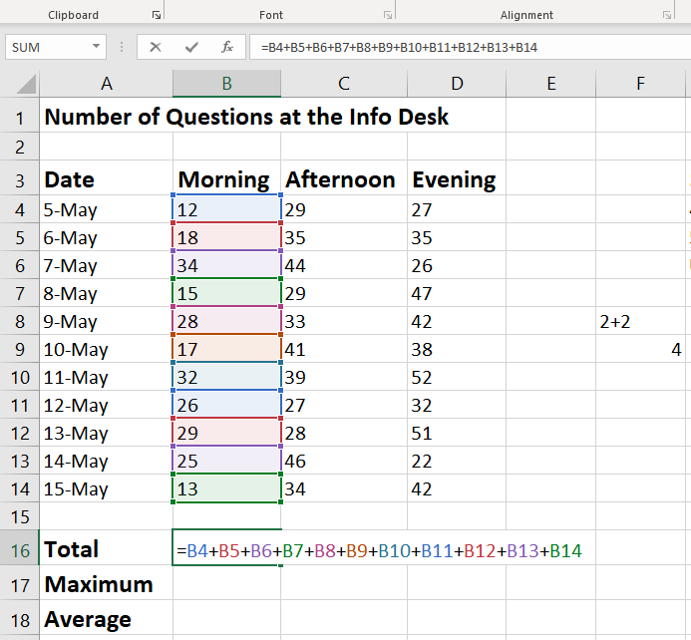

Functions and Cell Ranges

In the previous example in order to calculate the total questions asked at the Info desk in the mornings, we typed out our formula with the entire string of cell references. Excel has features called functions—essentially premade formulas—that make it much easier and faster to do calculations such as this.

Like formulas, functions begin with an equal sign (=), after which you type the name of the function, followed by the function inputs in parentheses. As an example, one of the most commonly used functions is the SUM function, which simply adds a bunch of numbers together. To use the SUM function, type =sum followed by the values or cells you wish to add, separated by commas and in parentheses.

One of the great things about functions is that they allow you to use a cell range instead of typing all the individual cell addresses. A cell range represents a range of cells and is denoted by a colon (:) separating the first and last cells of that range. For example, C4:C14 refers to cells C4, C5, C6…C14. We can use this with the SUM function to quickly add up the total number of afternoon questions at the Info Desk by typing =sum(C4:C14).

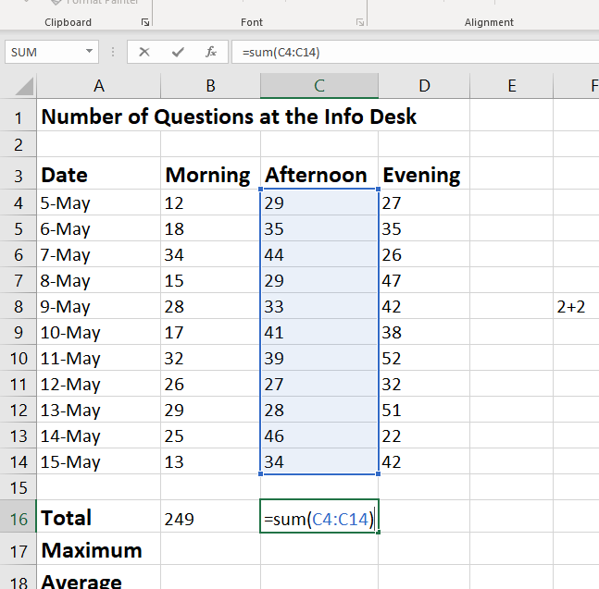
There are many other Excel functions besides SUM. The other functions can be found using the Insert Function button next to the formula bar or from the Formulas ribbon. Alternatively, you can type out the functions if you know their names. Try using what you’ve learned so far to complete the rest of the table on this worksheet.

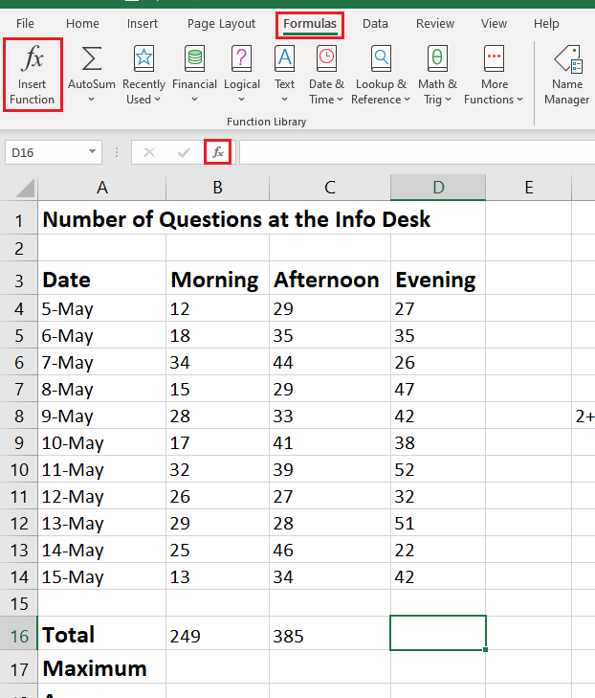
[switch from sheet4 to sheet5]

Relative Cell References vs Absolute Cell References

You can use the fill handle to copy formulas as well as values. For example, we can type out the formula for one person’s salary, and then use the fill handle to apply this formula for everyone else in our table.

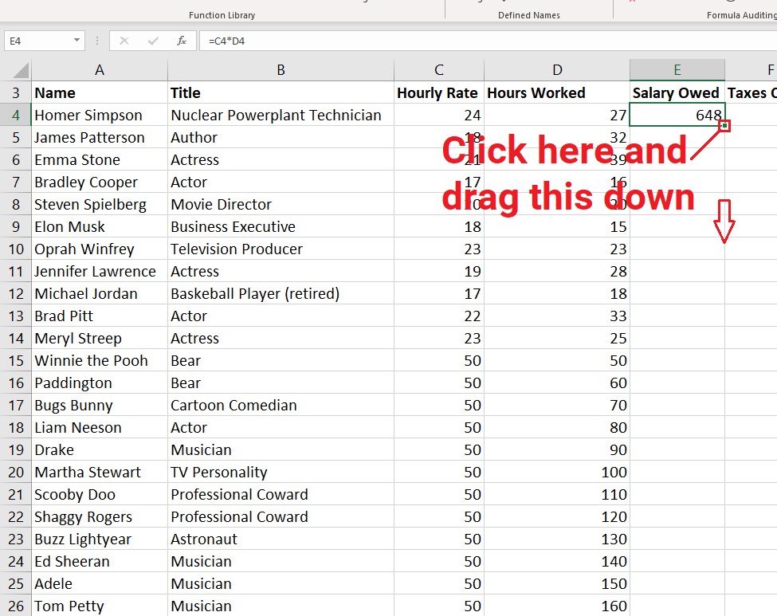

Notice that after filling the Salary Owed column, the cell references in each formula changes to correctly reflect the different rows. Because the cell references in each Salary Owed formula changes, these are called “relative cell references.”

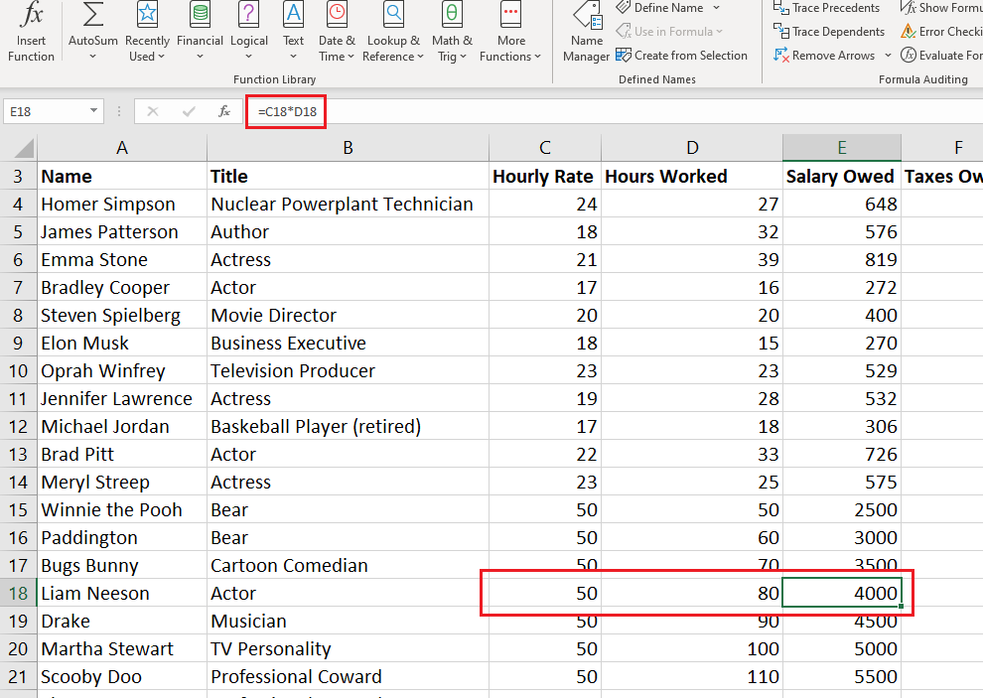

Sometimes you will want all formulas in a column to refer to a fixed number. Such is the case when calculating taxes, since the same tax rate applies to each row. By referring to this fixed number, you can easily change the tax rate later and have the change automatically apply to the entire column without having to make changes to each formula.

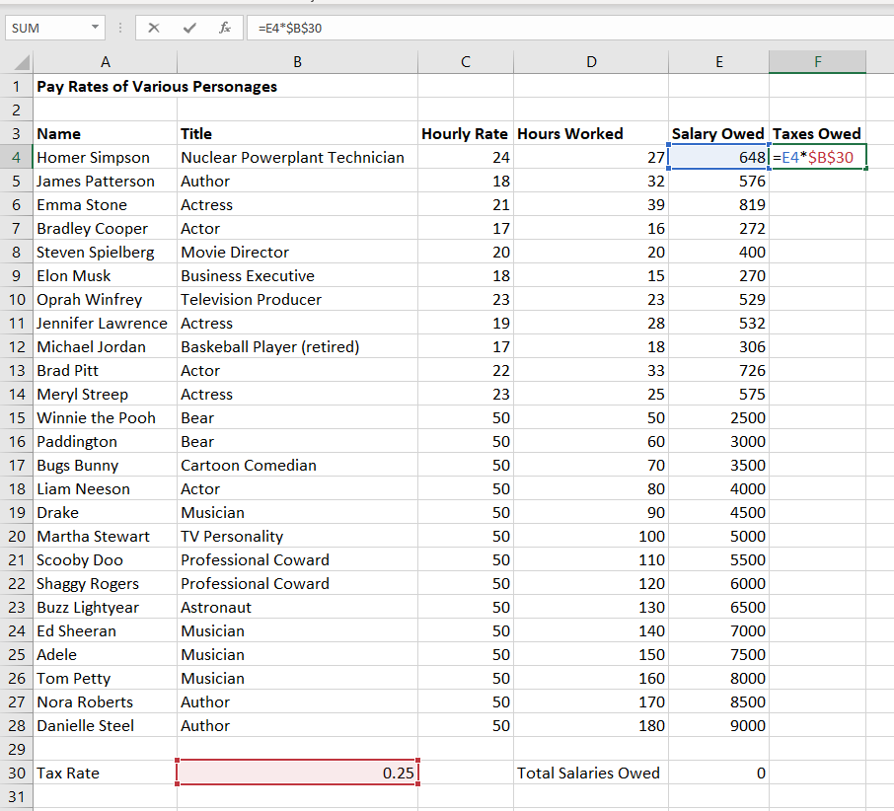

In this example, we want to calculate the Taxes Owed for each employee using the fill handle without having to type cell B30 each time. To do this, insert a $ in front of the column AND row when referencing cell B30 in the formula. This is called an absolute cell reference.
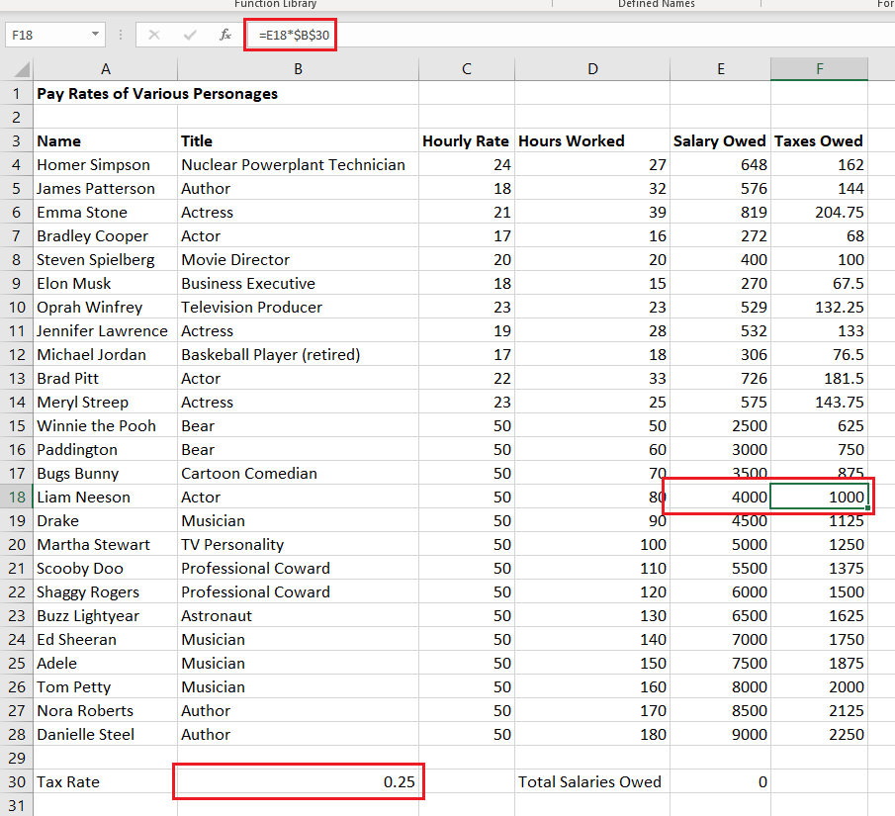

Sorting Data

Excel can sort data that is in table form. For this to work, the cells containing your data need to be adjacent to one another. Once your cells are arranged correctly, select a cell within your table and use the Sort buttons on the Data ribbon to sort one or more rows or columns.

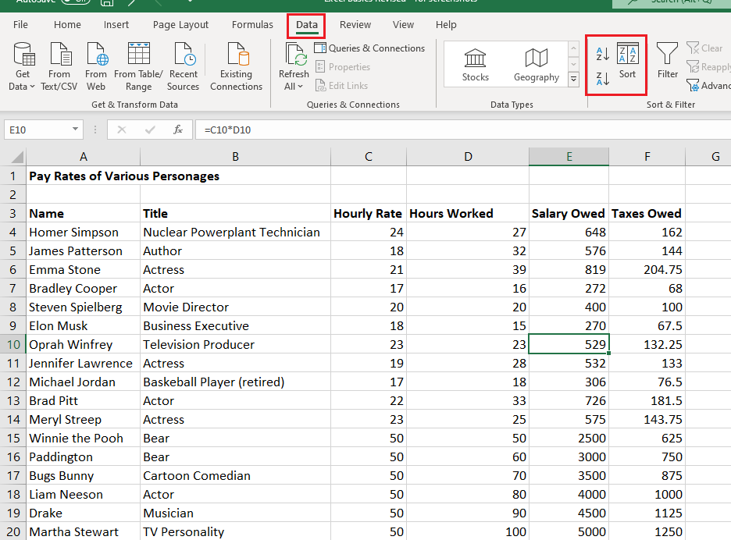

Freezing Panes

If you have a large table that doesn’t fit on one sheet, you may want to freeze a row or column so that it stays visible when you scroll to another part of your worksheet. To do this, select the row below or the column to the right of the one you wish to freeze and left click the Freeze Panes button on the View ribbon. You can unfreeze a frozen pane by using the same button.

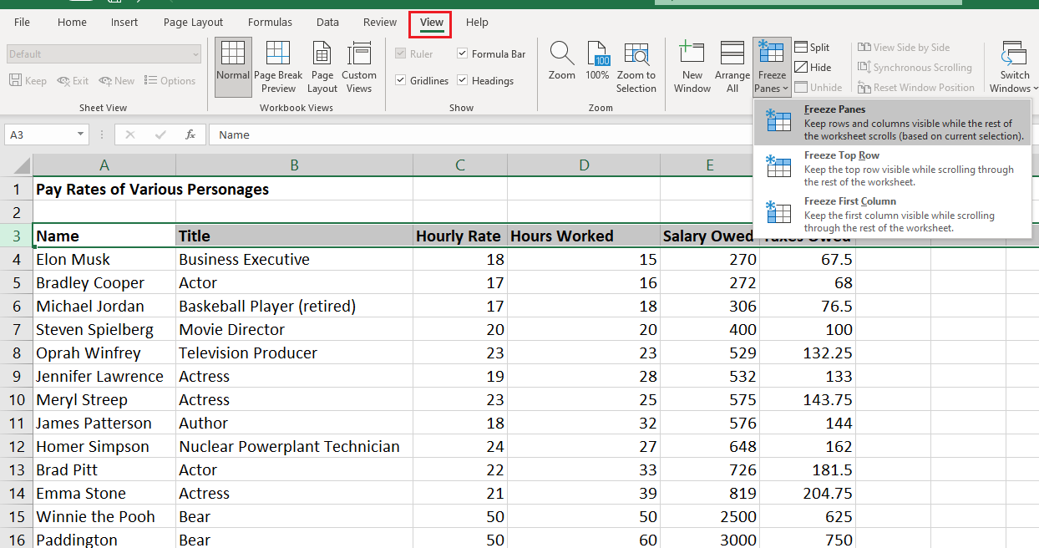

Printing Options

Excel has printing options similar to Microsoft Word on the Page Layout ribbon, such as the ability to change the margins or orientation. Excel does not print gridlines by default. If you want to include these lines in your printed document, check the Gridlines -> Print checkbox on this ribbon.

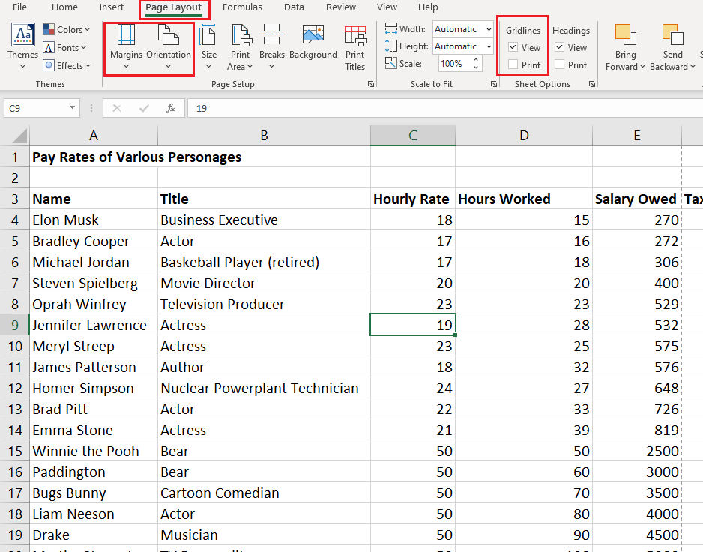

Additional Resources

Tutorials for Excel and other skills can be found at:
- LinkedIn Learning: https://www.linkedin.com/learning-login/go/palatinelibrary
- GCFGlobal: https://edu.gcfglobal.org/en/

