JULY 7: HOT DOG DAY

Hot dog – a tube-like meat product made from ground inexpensive meat. It can be grilled (on a barbeque grill), boiled or microwaved easily. A traditional food at baseball games, picnics, and hot dog stands.

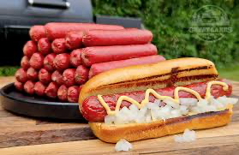

Condiment – Things added to a sandwich like on a Chicago Hot Dog (mustard, pickle relish, onion, celery salt, tomato, pickle spear). The condiment ketchup is not included on a Chicago Hot Dog.

Picnic – an informal meal held outdoors with food that is brought.

Bun – A bread that holds the hotdog and condiments. A Chicago Hot Dog will often have a sesame seed bun.

Chips – Crispy, salty snacks often made from potatoes

Watermelon – a large fruit that is often red. It is very watery and sweet and great for a snack or dessert
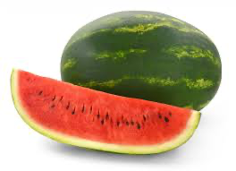
Utensils – Tools for eating like forks, spoons, and knives

Cooler - container for keeping food and drinks cold 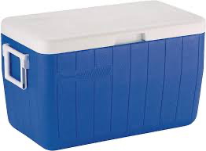

Ants – crawling insects that love picnics

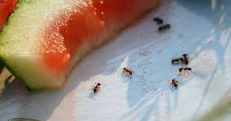

Mosquito (plural: mosquitoes) – an insect that flies and bites as it sucks your blood. It often causes an itchy bump on the skin. Often killed as you slap it, leaving a bloody mess on your skin.
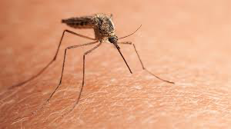

Exercise: Select a word to fill in the blanks. Use plural nouns where appropriate:

Hot dog mosquito salad bun utensil watermelon picnic cooler condiment chips

A family went on a _________________ in the park for a relaxing meal on Saturday. They were prepared for the day. They brought all their food and drinks in a _________________ , so it would stay cold while they walked through the park. They were going to put the _____________________ in the ______________ to make a sandwich. They would add ______________________ like mustard and pickles.
They had potato ________________ as a side dish to go with the meal and _______________________ for dessert. They brought _____________________ like forks and knives in case anyone needed them. They brought bug spray to keep the ______________________ from biting them and the ________________ from eating their food.

